Management system user guide

**Project** **2**

Create a project 2

Edit a project 3

Remove a project 4

Add a new team member to a project 5

Edit information about a project team member 6

Remove team member from a project 7

**Requirement** **8**

Add a new requirement to a project 8

Edit a requirements information 9

Remove requirement from a project 10

**Task** **11**

Add a new task to a requirement 11

Add team member to a task 12

Remove team member from a task 13

Edit a tasks information 14

Remove a task from a requirement 15

# Project

## Create a project

1. Click on “Add Project”
2. Enter a project title
3. Customer name
4. Project description
5. Choose a deadline
6. Then click on save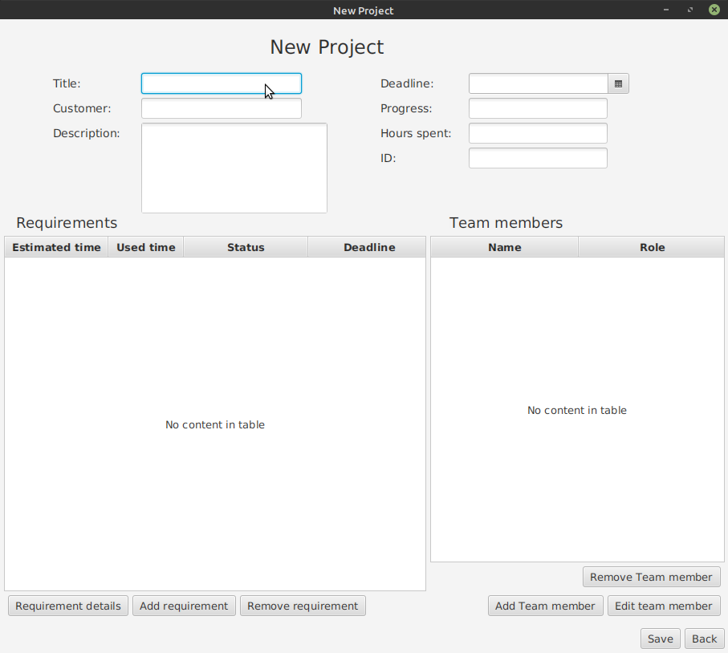

## 

## 

## Edit a project

1. Chose the project you want to edit
2. Click open
3. Enter changed information
4. Click save

## 

## Remove a project

1. Select the project you want to remove
2. Click on remove
3. Choose OK in the confirmation box

## 

## Add a new team member to a project

1. Select a project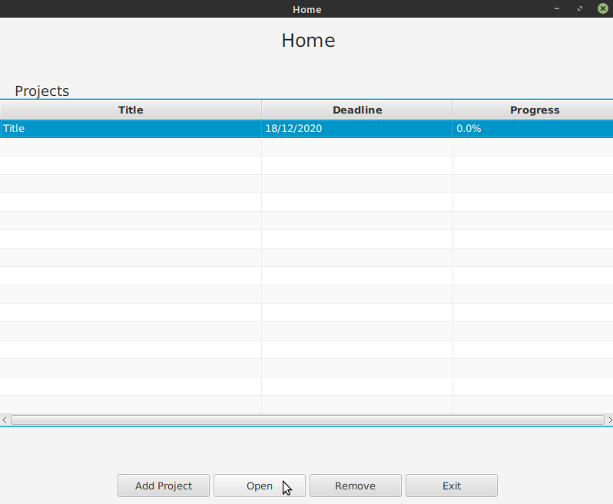
2. Click on open
3. Click on add team member
4. Enter name and choose a role
5. Click save

## 

## Edit information about a project team member

1. Select a project
2. Click on open
3. Select a team member
4. Click “Edit team member”
5. Enter a different name or chose a new role
6. Click save

## 

## Remove team member from a project

1. Select a project
2. Click on open
3. Select a team member
4. Click “Remove Team member”
5. Click on OK in confirmation window

# 

# Requirement

## Add a new requirement to a project

1. Select a project
2. Click on open
3. Click on Add requirement
4. Choose a responsible team member
5. Enter description
6. Choose a deadline
7. Choose a priority
8. Enter estimated time
9. Click save

## 

## Edit a requirements information

1. Select a project
2. Click on open
3. Select a requirement
4. Click on Requirement details
5. Enter new details
6. Click on save

## 

## Remove requirement from a project

1. Select a project
2. Click on open
3. Select a requirement
4. Click on Remove requirement
5. Click OK in confirmation window

# 

# Task

## Add a new task to a requirement

1. Select a project
2. Click on open
3. Select a requirement
4. Click on Requirement details
5. Click on Add
6. Enter a title for the task
7. Choose a responsible team member
8. Choose a deadline
9. Enter estimated time
10. Click save

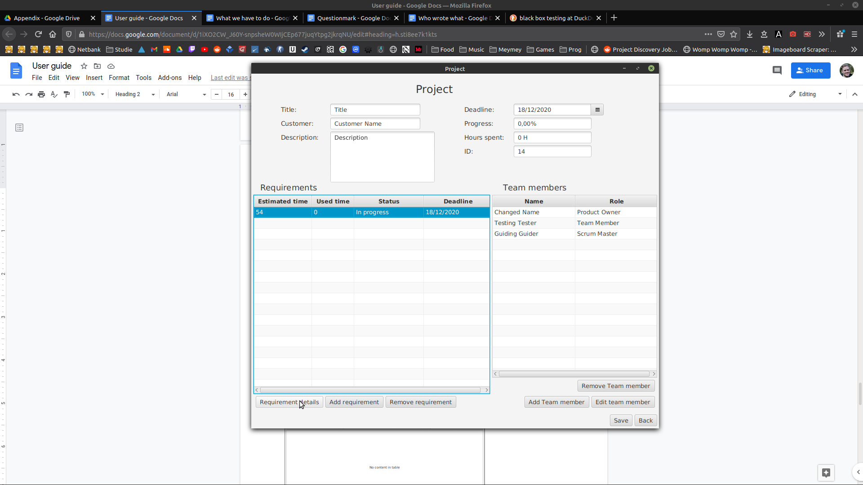

## 

## Add team member to a task

1. Select a project
2. Click on open
3. Select a requirement
4. Click on Requirement details
5. Select a task
6. Click on Open
7. Click on Add
8. Choose a team member
9. Click Add

## 

## Remove team member from a task

1. Select a project
2. Click on open
3. Select a requirement
4. Click on Requirement details
5. Select a task
6. Click on Open
7. Select a team member
8. Click on Remove

## 

## Edit a tasks information

1. Select a project
2. Click on open
3. Select a requirement
4. Click on Requirement details
5. Select a task
6. Click on Open
7. Enter new information
8. Click on Save

## 

## Remove a task from a requirement

1. Select a project
2. Click on open
3. Select a requirement
4. Click on Requirement details
5. Select a task
6. Click on Remove
7. Click OK in confirmation window